Phase 3 - Project Design Phase

Design Overview

The solution is designed as one UI Policy with two policy actions and three Client Scripts. All of them work on the Incident table. The UI Policy handles field-level rules, and the Client Scripts handle automatic value setting, save validation, and list-edit control.

Component Design

Component | Type | Trigger / Condition | Action
High Impact Control | UI Policy | Impact is 1 - High | Assignment Group mandatory; reverse if false enabled
Urgency policy action | UI Policy Action | Impact is 1 - High | Urgency field set to read-only
Auto set urgency for high impact | Client Script (onChange) | Impact field changes | Urgency set to 1 - High and info message shown
Prevent save if Assigned To missing | Client Script (onSubmit) | Impact High and Assigned To empty | Error message shown, save blocked
Prevent state change via list edit | Client Script (onCellEdit) | State edited from list | Alert shown, change cancelled

Logic Flow of the Incident Form

The flowchart below shows how the Incident form behaves after the design is implemented.
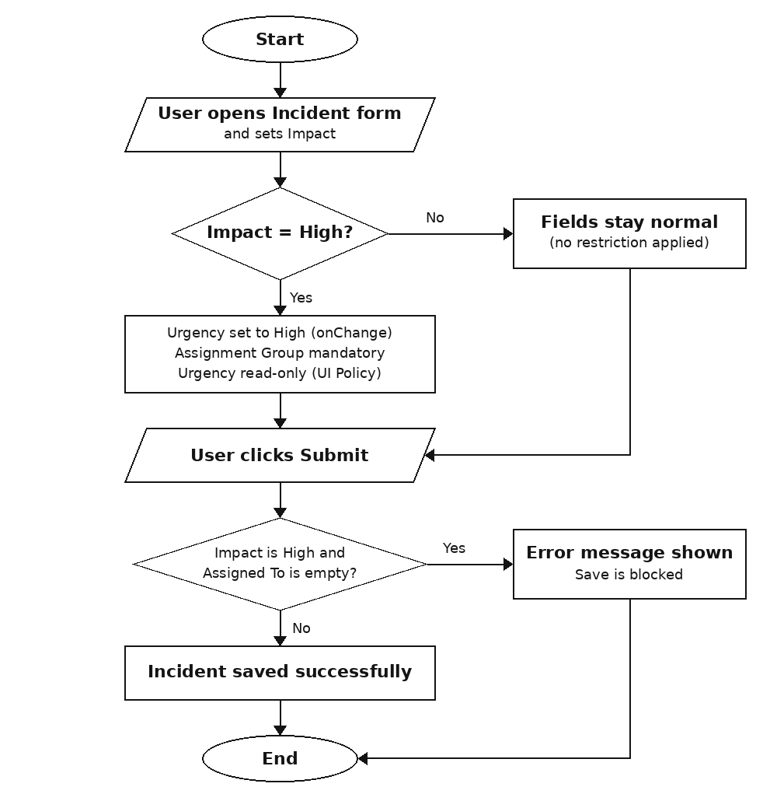
Figure: Incident form logic flow

Design Decisions

- The Reverse if false option is enabled so that restrictions are removed automatically when Impact changes from High to another value.
- List editing of State is blocked, but form editing is allowed, so State changes still have a controlled path.
- Each rule is kept in a separate script or policy so it can be tested and changed independently.

